Trader Performance vs. Bitcoin Market Sentiment
An Analysis of Hyperliquid Trading Data Against the Fear & Greed Index
PrimeTrade.ai — Data Science Hiring Assignment (Round 0)

1. Objective
This analysis explores the relationship between trader performance on Hyperliquid and the prevailing Bitcoin market sentiment, as measured by the Fear & Greed Index. The goal is to uncover behavioral patterns that differentiate high-performing traders from the rest, and to surface insights that could inform smarter, sentiment-aware trading strategies.

2. Data & Methodology
Two datasets were used:
- Historical Trader Data (Hyperliquid): individual trade-level records including account, execution price, position size, side, closed PnL, and timestamp.
- Bitcoin Fear & Greed Index: a daily sentiment score with five classifications — Extreme Fear, Fear, Neutral, Greed, and Extreme Greed.
The two datasets were merged on a common calendar date. During this step, the trader dataset's raw millisecond epoch timestamp was validated against its parallel human-readable IST timestamp column to confirm correct date alignment before merging — an important check, since a naive conversion of the epoch field alone produced a mismatched date range. After alignment, 211,224 of 211,230 trade records (99.997%) matched to a sentiment classification.
A trade was defined as a "win" if Closed PnL > 0. Traders were ranked by total realized PnL across the full period, and the top 10% by cumulative PnL were isolated as an "elite" cohort for comparison against the remaining 90%.

3. Overall Performance by Market Sentiment
Across all traders, win rate and profitability both varied meaningfully with sentiment regime:
Sentiment | Total Trades | Avg PnL ($) | Avg Trade Size ($) | Win Rate (%)
Extreme Fear | 21,400 | 34.54 | 5,349.73 | 37.06
Fear | 61,837 | 54.29 | 7,816.11 | 42.08
Neutral | 37,686 | 34.31 | 4,782.73 | 39.70
Greed | 50,303 | 42.74 | 5,736.88 | 38.48
Extreme Greed | 39,992 | 67.89 | 3,112.25 | 46.49

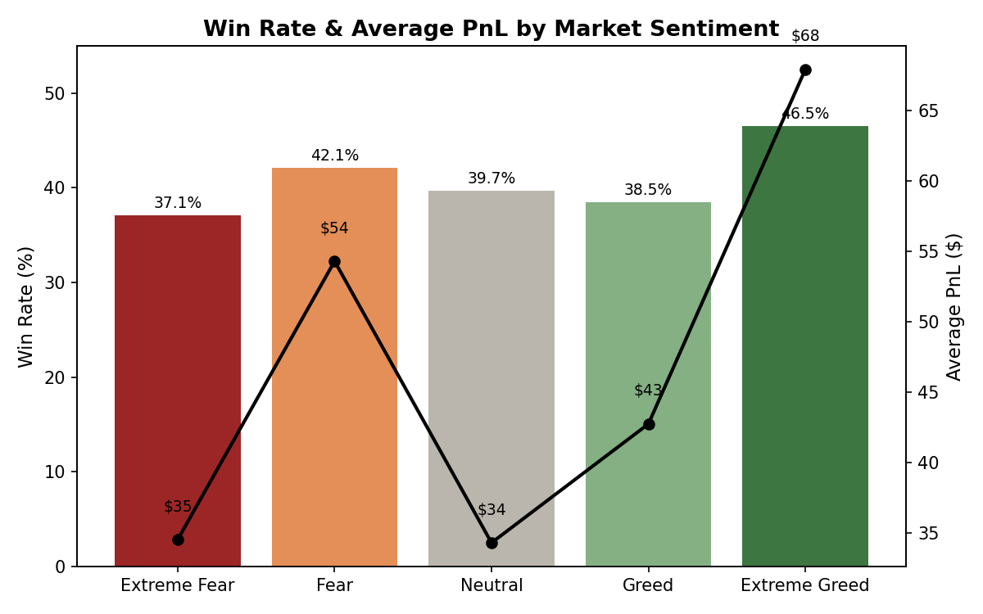
Win rate is highest during Extreme Greed (46.5%) and lowest during Extreme Fear (37.1%), consistent with the intuition that trending, momentum-driven markets are easier to trade profitably on a per-trade basis. Interestingly, average trade size peaks during Fear (not Extreme Fear or Greed), suggesting traders scale up conviction during moderate fear — a pattern consistent with contrarian dip-buying behavior.

4. Elite Traders (Top 10%) vs. The Rest
Isolating the top 10% of traders by total realized PnL reveals a sharper story than sentiment alone:
Tier | Sentiment | Avg PnL ($) | Avg Trade Size ($) | Win Rate (%)
Other 90% | Extreme Fear | 26.31 | 5,622.79 | 37.24
Other 90% | Fear | 30.09 | 4,722.24 | 40.60
Other 90% | Neutral | 12.11 | 3,117.98 | 37.02
Other 90% | Greed | 28.93 | 2,990.48 | 40.48
Other 90% | Extreme Greed | 44.38 | 2,882.13 | 47.59
Top 10% | Extreme Fear | 57.39 | 4,591.30 | 36.58
Top 10% | Fear | 94.59 | 12,968.25 | 44.53
Top 10% | Neutral | 90.54 | 9,000.58 | 46.49
Top 10% | Greed | 101.05 | 17,326.10 | 30.04
Top 10% | Extreme Greed | 378.88 | 6,156.07 | 32.05

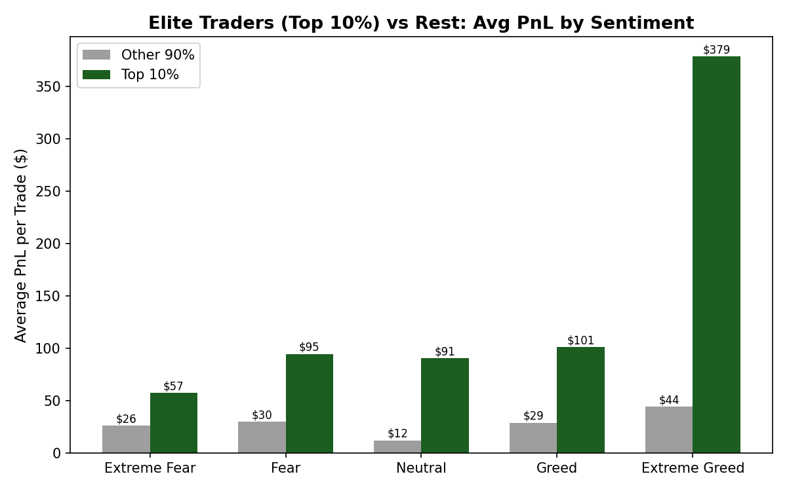
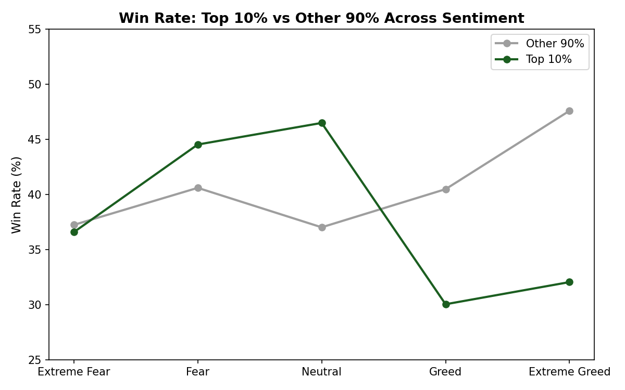

5. Key Insights
- Elite traders win big, not often. In Greed and Extreme Greed regimes, the Top 10% cohort actually has a LOWER win rate than the Other 90% (30.0% vs 40.5%, and 32.1% vs 47.6%, respectively) — yet their average PnL per trade is 3.5x to 8.5x higher. This is the signature of asymmetric position sizing: letting winning trades run and cutting losers quickly, rather than optimizing for hit rate.
- Conviction scales with trade size, not just frequency. The Top 10%'s average trade size during Greed ($17,326) is nearly 6x the Other 90%'s ($2,990). Elite traders appear to concentrate capital into higher-conviction setups during trending markets rather than spreading risk evenly.
- The edge compresses during Extreme Fear. This is the one regime where Top 10% and Other 90% win rates converge (36.6% vs 37.2%) — suggesting that even skilled traders struggle to find a statistical edge in genuinely panicked markets. Their PnL advantage here (57.39 vs 26.31) still holds, but is driven more by capital preservation and sizing discipline than by superior trade selection.
- Extreme Greed offers the single best risk-adjusted opportunity for skilled traders. The Top 10%'s average PnL of $378.88 in Extreme Greed dwarfs every other combination in the dataset — nearly 4x their next-best regime (Fear, $94.59) — despite a relatively modest trade size, implying the edge here comes from trade selection and timing rather than sheer capital deployed.

6. Strategic Recommendations
- Use sentiment as a position-sizing signal, not just a directional one. The data suggests conviction-weighted sizing (larger positions in Fear/Greed extremes where the elite cohort's edge is clearest) outperforms uniform sizing across regimes.
- Treat Extreme Fear as a capital-preservation regime. With win rates converging across skill tiers, this is where risk controls (tighter stop-losses, reduced size) likely matter more than aggressive trade-picking.
- Investigate the Extreme Greed opportunity further. Given the outsized PnL edge for top traders at moderate trade sizes, a follow-up analysis of holding periods and entry/exit timing in this regime specifically could isolate the exact mechanism driving the outperformance.

7. Limitations
This analysis merges data at the daily level, so intraday sentiment shifts are not captured. The 'Top 10%' cohort is defined by total cumulative PnL, which can be influenced by account longevity and capital base rather than skill alone. Leverage and position-holding duration were not available in this dataset and would meaningfully deepen the asymmetric-sizing hypothesis if incorporated in future work.

